OBJECT ORIENTED ANALYSIS
Analysis emphasizes on investigation of the problem rather than how a solution is defined.
“What the problem is about and what the system must do?”
Design emphasizes on a logical solution, how the system fulfill the requirements.
In Object Oriented analysis, the main emphasis is on finding and describing the objects or concepts in the problem domain. e.g. in Library system some concepts may include book, library.
Requirements Process:
Capabilities and conditions to which the system and more broadly, the project must conform
A prime challenge of requirements work (fact finding) is to find, communicate, and record what is really needed, in a form that clearly speaks to the client and development team members.
Types of requirements:
i. Functional (behavioral)
- calculations, technical details, data manipulation and processing and other specific functionality
ii. Non-functional (everything else);
- also known as quality requirements, which impose constraints on the design or implementation (such as performance requirements, security, cost and reliability).
Types of Requirements: FURPS+
An acronym representing a model for classifying software quality attributes (functional & non-functional requirements), First Developed at HP
Functionality—features, capabilities, security.
Usability—human factors, help, documentation.
Reliability—frequency of failure, recoverability, predictability
Performance—response times, throughput, accuracy, availability, resource usage
Supportability—adaptability, maintainability, internationalization, configurability.
The "+" in FURPS+ indicates ancillary and sub-factors, such as:
Implementation—resource limitations, languages and tools, hardware, ...
Operations—system management in its operational setting.
Packaging Legal—licensing and so forth.
Fact Finding and Requirements Elicitations
In order to identify all relevant requirements analysts must use a range of techniques:-
- Fact-Finding Overview
  - First, you must identify the information you need
  - Develop a fact-finding plan
Fact finding can be done thru Document review, observation, questionnaire, surveys, sampling, research.
Interviewing
The analyst starts by asking context-free questions;
- a set of questions that will lead to a basic understanding of the problem, the people who want a solution, the nature of the solution desired, and the effectiveness of the first encounter itself.
Structured Questioning Techniques usually lead by software engineer :
–why are we building this system
–who are the other users
–determine critical functionality
Open-ended questions
–useful when not much is known yet
–examples "describe X " tell me what you do
Closed-ended questions
–when enough about the system is known try to ask specific questions
–example "how often should sales reports be generated?”
Try to proceed from open-ended to closed-ended questions!!
-rephrase answers to confirm the customer’s needs
–make sure you understood the client's answer, check for errors, inconsistencies and
ambiguities
Find out who else to interview

–who else uses the system
–who interacts with you
–who will agree / disagree with you

The Q&A session should be used for the first encounter only and then be replaced by a meeting format that combines elements of problem solving, negotiation, and specification.
Customers and software engineers often have an unconscious "us and them" mindset.
Rather than working as a team to identify and refine requirements, each constituency defines its own "territory" and communicates through a series of memos, formal position papers, documents, and question and answer sessions.
Facilitated Application Specification Technique (FAST)
Facilitated Application Specification Techniques (FAST), this approach encourages the creation of a joint team of customers and developers who work together to identify the problem, propose elements of the solution, negotiate different approaches, and specify a preliminary set of requirements.
The idea is to overcome we/them attitude between developers and users team-oriented approach
Guidelines
–participants must attend entire meeting
–all participants are equal
–preparation is as important as meeting
–all pre-meeting documents are to be viewed as “proposed”
–off-site meeting location is preferred
–set an agenda and maintain it
–don’t get mired in technical detail
Approaches to FAST
–Joint Application Design (IBM)
–The Method (Performance Resources)
JAD stands for Joint Application Development.
Sit down with the client and design a paper UI that they can see what the application will look like and behave like.
Give the user a chance to work through common scenarios and see if the application will work for them.
Keep refining until the user feels the application is doing what they want it to do.
As you get functionality implemented, bring the user in and have them work through those scenarios and see if it still works.
If they want a change, have a solid estimate of how long the change will add to the schedule and how much it will cost.
The UML and Development Process
UML only standardized artifacts and notations, but it does not define a standard development process
- To increase the likelihood of wide spread acceptance of a standard modeling notation.
- There is lot of variation in deciding what constitutes an appropriate process, depending upon the staff skill, research, development ratio, nature of problem, tools and so on.
MACRO STEP LEVELS:
Major steps in S/W development includes
- Plan and Elaborate; planning defining requirements, building proto-types
- Build: Construction of the system.
- Deploy: The implementation of the system into use…..
Macro level steps in development:
Iterative Development:
- It is based on successive enlargement and refinement of a system through multiple developments cycles.
- Each cycle tackles a relatively small set of requirements, proceedings through analysis, design, construction and testing.
- The system grows incrementally as each cycle is completed.
The identified advantages:
- The complexity is reduced
- Early feedback as implementation occurs rapidly for a small subset of the system.

Iterative development cycle:
- Time- boxing & Development cycle
- The development is bound within a time box, a rigidly fixed time, such as four weeks.
- To succeed, it is necessary to choose the requirements carefully.
Use Cases and Iterative Development cycle
- A use case describes narrative description of a domain process
- A development cycle is assigned to implement one or more use cases.
- Use cases should be ranked, with high ranking use cases to be tacked first.
- The strategy is to first pick the use case that significantly influences the core architecture.
The Plan and Elaborate phase.
Build Phase – Development cycle.
- A repeated development cycle within which the system is extended
- The final objective is to have a working software system that correctly meets the requirements.
Order of Development cycle artifact creation
Some artifacts may be developed in parallel such as
- Conceptual model and glossary
- Interaction diagram and class diagrams
Choosing when to create artifacts:
Draft conceptual model
Expand use cases
These are created during early plain and elaborate phase.
The conceptual model should be created where the emphasis is on finding obvious concepts expressed in requirements while deferring a deep investigation.
The conceptual model should be incrementally refined and extended later within the development cycle.
Defining Models and Artifacts
Models in OOAD are dependent relationship between artifacts (objects)
Modeling Systems
- Systems are inherently complex
- Divide and conquer more appropriate (decompose into understandable chunks)
- Chunks are represented as models
All software systems should be developed by creating models. (which organize and communicate important details of the real world problems it is related to and of the system)
A. Building Conceptual/Domain Models
It is a major activity in the development cycle.
Conceptual/Domain Models
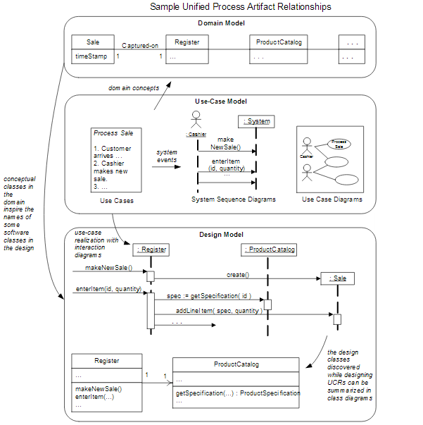
A conceptual/domain model is a representation of concepts in a problem domain.
In UML it is a static structure diagrams in which no operations are defined.
A domain model illustrates meaningful (to the modelers) conceptual classes in a problem domain; it is the most important artifact to create during object-oriented analysis.
A domain model is a representation of real-world conceptual classes, not of software components.
It is not a set of diagrams describing software classes or software objects with responsibilities.
Using UML notation, a domain model is illustrated with a set of class diagrams in which no operations are defined.
It may show:
- domain objects or conceptual classes
- associations between conceptual classes
- attributes of conceptual classes
It must not show:
- software artifacts such as window or database
- responsibilities or methods
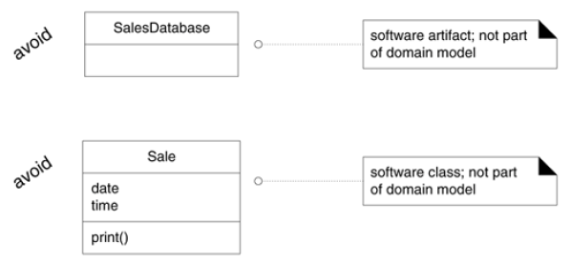
OOA deals with the Decomposition of a domain into noteworthy concepts or objects
Domain Modeling — visual representation of domain concepts in simple UML
- Other names: conceptual models, domain object model, analysis object model
- Bounded by a specific domain as described in use cases
- Concepts are not software classes (these are in domain layer )
In object Oriented design the emphasis is on defining logical software objects that will ultimately be implemented in an object oriented programming language.
Three steps for Creating a Domain Model
i. Find the domain concepts
ii. Draw them in a UML class diagram
iii. Add associations and attributes
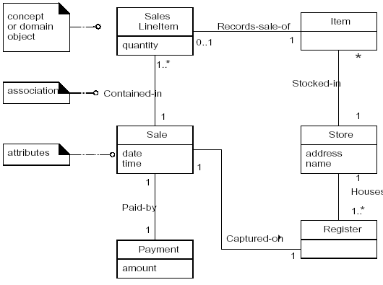
• Domain concepts — noteworthy abstractions, domain vocabulary idea, thing or object
e.g Payment, Sale
• Associations — relationships between concepts e.g. Payment Pays-For Sales
• Attributes – information content e.g. Sale records date and time
It can be viewed as a model that communicates what the important terms are, and how they are related.
i. Domain Model : Identifying Conceptual Classes
The domain model illustrates conceptual classes or vocabulary in the domain.
Informally, a conceptual class is an idea, thing, or object. More formally, a conceptual class may be considered in terms of its symbol, intension, and extension
• Symbol—words or images representing a conceptual class.
• Intension—the definition of a conceptual class.
• Extension—the set of examples to which the conceptual class applies.
Conceptual class for the event of a purchase transaction:
Name : Sale.
Intension: represents the event of a purchase transaction, and has a date and time.
Extension: All the examples of sales; in other words, the set of all sales.
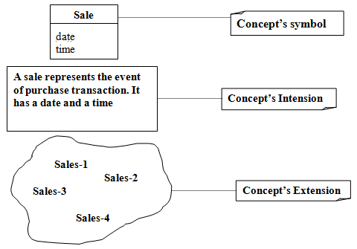
Name : Card
Intension: represents one card in a poker deck that has a rank (2..14) and a suit
Extension: the set of all cards
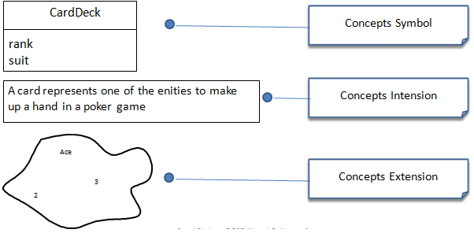
Domain Models and Decomposition: Software problems can be complex; decomposition—divide-and-conquer—is a common strategy to deal with this complexity by division of the problem space into comprehensible units.
In structured analysis, the dimension of decomposition is by processes or functions.
In object-oriented analysis, the dimension of decomposition is fundamentally by things or entities in the domain.
Strategy to Identify Concepts
Two techniques are presented in the following sections:
i. Use a conceptual class category list.
ii. Identify noun phrases.
i. Finding Concepts with the Concept Category List: Start the creation of a domain model by making a list of candidate conceptual classes.
Conceptual Class Category | Examples
Business Transactions  Guidelines: Critical concepts (involves money) | Sale, Payment  Reservation
Transaction line items  Guideline: transactions often come with related line items, | SaleLineItems
Product ore service related to a transaction or transaction line item related  Guideline: Transactions are for something (a product or service) | Flight, item, seat, meal
Where is the transaction recorded? | Register,ledger, flightManifest
Roles of people or organizations related to the transaction: actors in the use case  Guideline: It is desirable to know about the parties involved in a transaction | Cashier, customer, airline, passenger,  Pilot
Place of transaction: place of service | Store, airport, plane , seat
Noteworthy events, often with a time or place we need to remember | Sale, payment, flight
Physical or Tangible objects  Guidelines: especially relevant when creating device control software or simulations | POST, die, Airplane, board, item
Specification, design or description of things | ProductSpecification, FlightDescription
Catalogues | ProductCatalogue, PartCatalogue
Containers of other things | Store, Bin  Airplane
Things in a container | Item, square, passenger
Other collaborating items | CreditAuthorizationSystem, AirTrafficControl
Record of finance, work, contracts, legal matters | Receipt, ledger logs
Places | Store, Airport
Financial instruments | Cash, check, lineofCredit
Schedules, manuals, documents that are regularly referred to in order to perform work | dailyPriceChangeList, repairSchedule

ii. Finding Concepts with the Noun Phrase Identification: Identify the Noun and the Noun Phrase in the textual description in the Problem Domain and consider them as candidate concepts or attributes
Main Success Scenario (or Basic Flow):
1. Customer arrives at a POS checkout with goods and/or services to purchase.
2. Cashier starts a new sale.
3. Cashier enters item identifier.
4. System records sale line item and presents item description, price, and running
total. Price calculated from a set of price rules.
Cashier repeats steps 2-3 until indicates done.
5. System presents total with taxes calculated.
6. Cashier tells Customer the total, and asks for payment.
7. Customer pays and System handles payment.
8. System logs the completed sale and sends sale and payment information to the
external Accounting (for accounting and commissions) and Inventory systems (to
update inventory).
9. System presents receipt.
10.Customer leaves with receipt and goods (if any).
Extensions (or Alternative Flows):
7a. Paying by cash:
1. Cashier enters the cash amount tendered.
Candidate Conceptual Classes for the Sales Domain
From the Conceptual Class Category List and noun phrase analysis, a list is
generated of candidate conceptual classes for the domain.
The list is constrained to the requirements and simplifications currently under consideration—the simplified scenario of Process Sale.

Register
Item
Store
Sale
Payment
ProductCatalog
ProductDescription
SalesLineItem
Cashier
Customer
Manager

The Process of Sale Conceptual Model (Concepts Only)
Register
Item
Store
Sales
Cashier
Customer
Product
Payment
Product Catalogue

Manager
Product Description

Domain Modeling Guidelines
1. List the candidate conceptual classes using the Conceptual Class Category List and noun
phrase identification techniques related to the current requirements under consideration.
2. Draw them in a domain model.
3. Add the associations necessary to record relationships for which there is a need to preserve
some memory
4. Add the attributes necessary to fulfill the information requirements

A Common Mistake in Identifying Conceptual Classes
Perhaps the most common mistake when creating a domain model is to represent something as an attribute when it should have been a concept.
The common rule :
If we do not think of some conceptual class X as a number or text in the real world, X is probably a conceptual class, not an attribute.
As an example, should store be an attribute of Sale, or a separate conceptual class Store?
Sale

Store
Sale

Store

phoneNumber
or…?

In the real world, a store is not considered a number or text—the term suggests a legal entity, an organization, and something occupies space. Therefore, Store should be a concept.
In Airline Domain, Will Destination be a concept of or an attribute Of Flight?
Flight

Destination
Flight

Airport

Name
or…?
Destination Airport is a massive thing that occupies space so it is a concept not an attribute
Specification or Description Concepts
Item
Description
Price
Serial Number
ItemID
ProductDescription Description
Price
UPC
ItemID
Item

serial number
1 Describes *

Description or specification objects are strongly related to the things they describe. In a domain model, it is common to state that an XDescription Describes an X
When Are Description Conceptual Classes Required?
Add a specification or description conceptual class (ProductDescription) when:
- There needs to be a description about an item or service, independent of the current existence of any examples of those items or services.
- Deleting instances of things they describe (for example, Item) results in a loss of information that needs to be maintained, due to the incorrect association of information with the deleted thing.
It reduces redundant or duplicated information.
Another example:
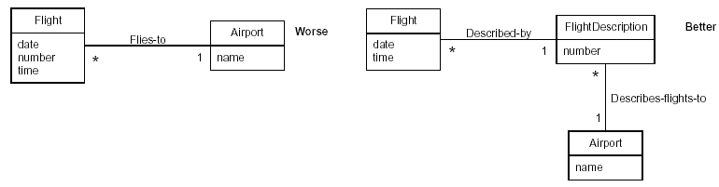
Why create a Domain Model?
Domain models are created to get a better understanding of the key concepts and vocabulary used in a particular domain. If it is required to develop a software for an aircraft manufacturing company, one should do proper domain modeling to understands the key concepts and jargons or technology specific words used there in order to be familiar with that domain. It helps in reducing the gap between the software representation and the mental model of the domain as perceived by the analyst.

ii. Domain Modeling : Adding Associations
Associations
It is a relationship between concepts that indicates some meaningful interesting connection.
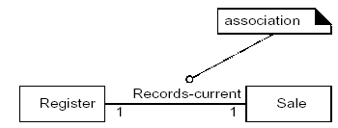
The UML Notation for association
An association is represented as a line between classes with an association name.
The association is inherently bidirectional, meaning that from instances of either class, logical traversal to the other is possible.
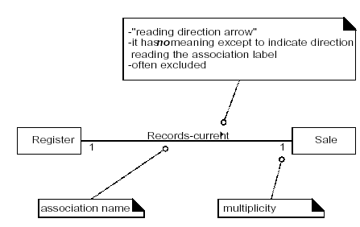

Finding Associations- Common Association List:
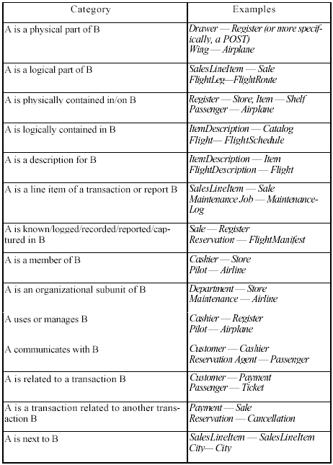
High Priority Associations
Some high-priority association categories that are invariably useful to include in a domain model:

A is a physical or logical part of B
A is a physically or logically contained in B
A is recorded in B

Association Guidelines
- Focus on those associations in which knowledge of the relationship needs to be preserved “need to know”
- It is more important to identify concepts then to identify associations
- Too many associations tend to confuse a domain model rather than illuminate it. Their discovery can be time-consuming, with marginal benefit.
- Avoid showing redundant or derivable associations.
Roles
Each end of an association is called a role. Roles may optionally have:

- name
- multiplicity expression
- navigability

i. Multiplicity
- It defines how many instances of A can be associated with one instance of a type B, at a particular moment in time.
For example, a single instance of a Store can be associated with "many" (zero or more, indicated by the * ) Item instances.
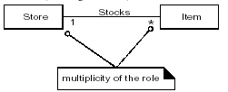
Some Examples of Multiplicity
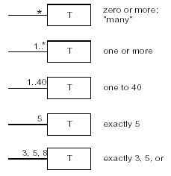
In UML the multiplicity value is context dependent

Naming Association
- Name an association based on a TypeName-VerbPhrase-TypeName format where the verb phrase creates a sequence that is readable and meaningful in the model context.
- Association names should start with a capital letter, since an association represents a classifier of links between instances; in the UML, classifiers should start with a capital letter.
Good: Sale PaidBy CashPayment Bad: Sale uses CashPayment
Good: Player IsOn Square Bad: Player has Square
Two common and equally legal formats for a compound association name are:
- Paid-by - PaidBy
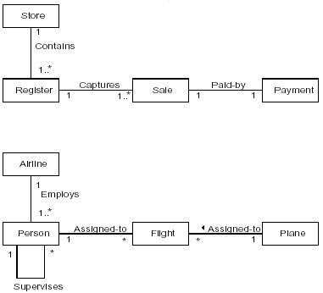
Multiple Associations between Two Types
Two types may have multiple associations between them; this is not uncommon.
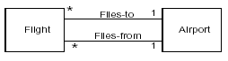
Applying the Category of Associations Checklist
Based on previously identified types and considering the current use case requirements.
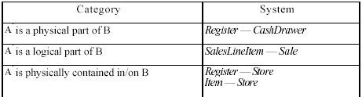
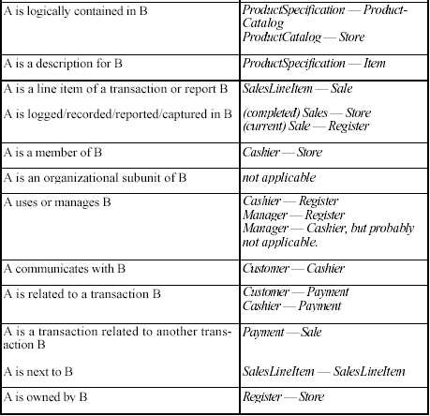

Point of Sale Domain Model
The figure below shows candidate concepts and associations for the POST system
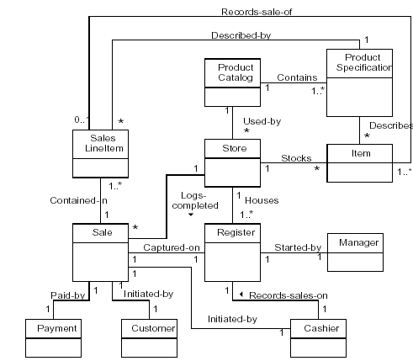

iii. Domain Model: Identifying Attributes
Attribute: It is a logical data value of an Object
UML Attribute Notation
Attributes are shown in the second compartment of the class box.
Their type may optionally be shown
The syntax for an attribute in the UML:
visibility name:type multiplicity = default {property-string}

Private visibility attributes
Public visibility attribute with initilization

-dateTime:Date
/total:Money
Sale

+pi:Real:3.14{readonly}
Math
Derived attribute

Optional value

firstName
middleName:[0 ..1]
lastName
Person

Valid Attribute Types
Keep Attributes Simple
Intuitively, most simple attribute types are what are often thought of as primitive data types, such as numbers.
The type of an attribute should not normally be a complex domain concept, such as a Sale or Airport.
For example, the currentRegister attribute in the Cashier class is undesirable because its type is meant to be a Register, which is not a simple attribute type (such as Number or String).
The most useful way to express that a Cashier uses a Register is with an association, not with an attribute.
The attributes in a domain model should preferably be simple attributes or data types.
Very common attribute data types include: Boolean, Date, Number, String(Text), Time
Other common types include: Address, Color, Geometries (Point, Rectangle),Phone Number, Social Security Number, Universal Product Code (UPC), SKU,ZIP or postal codes, enumerated types
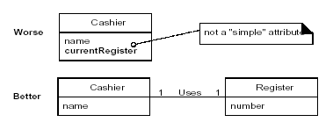
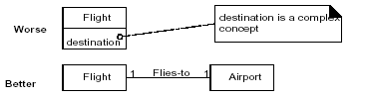
Data Types
Attributes should generally be data types. This is a UML term that implies a set of values for which unique identity is not meaningful.
For example, it is not meaningful to distinguish between:
• Separate instances of the Number 5.
• Separate instances of the String 'cat'.
• Separate instances of PhoneNumber that contain the same number.
• Separate instances of Address that contain the same address.
Non-Primitive Attribute Types
Represent what may initially be considered a primitive data type (such as a number or string) as a non-primitive class if:
- It is composed of separate sections.
- phone number, name of person
- There are operations usually associated with it, such as parsing or validation.
- social security number
- It has other attributes.
- promotional price could have a start (effective) date and end date
- It is a quantity with a unit.
- payment amount has a unit of currency
- It is an abstraction of one or more types with some of these qualities.
- item identifier in the sales domain is a generalization of types such as Universal Product Code (UPC) or European Article Number (EAN)
Attributes in the PoST Domain Model
The attributes chosen reflect the requirements for this iteration—the Process Sale scenarios of this iteration.
Payment
ProductSpecification
Sale
SalesLineItem
Store
amount—To determine if sufficient payment was provided, and to calculate change, an amount (also known as "amount tendered") must be captured.
description—To show the description on a display or receipt.
id—To look up a ProductSpecification, given an entered itemID, it is necessary to relate them to a id.
price—To calculate the sales total, and show the line item price.
date, time—A receipt is a paper report of a sale. It
normally shows date and time of sale.
quantity—To record the quantity entered, when there is more than one item in a line item sale (for example, five packages of tofu).
address, name—The receipt requires the name and address of the store.
The list of attributes should primarily be constrained to the requirements and simplifications currently under consideration.
Some attributes are clearly called for by reading Requirements specification
Current use cases under considerations Simplifications, clarifications, and assumption documents
e.g. It is necessary to record the date and time of a sale, therefore the sale concept requires a date and a time attribute.
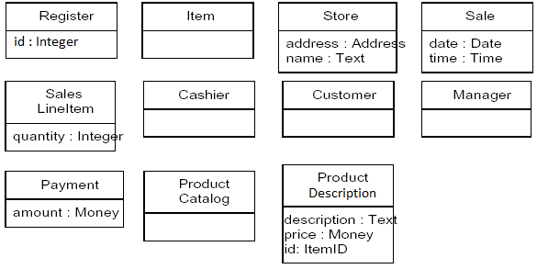

Discussion for POST Attributes
Payment: amount- In order to determine that sufficient payment was provided, and to calculate change, an amount must be entered.
ProductDescription: description- In order to show the description on a display or a receipt
UPC: upc- Inorder to look up ItemSpecification, given an entered UPC, it is necessary to relate them to a UPC
Price- In order to calculate the sales total
A partial domain model.
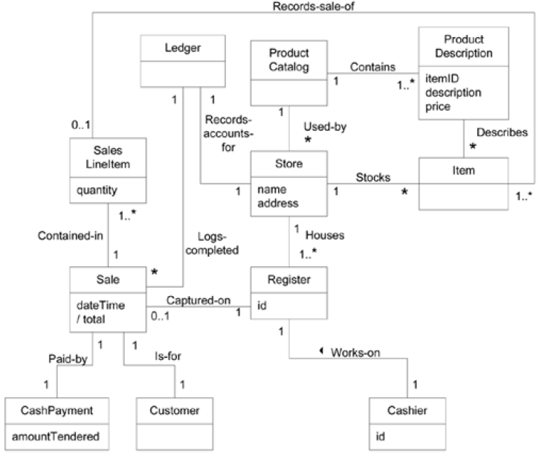
Multiplicity from SalesLineItem to Item
It is possible for a cashier to receive a group of like items (for example, six tofu packages), enter the itemID once, and then enter a quantity (for example, six).
Consequently, individual SalesLineItem can be associated with more than one instance of item.
The quantity that is entered by the cashier may be recorded as an attribute of the SalesLineItem .
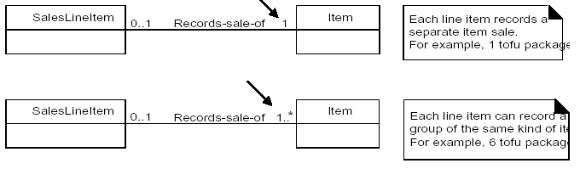
However, the quantity can be calculated from the actual multiplicity value of the relationship, so it may be characterized as a derived attribute—one that may be derived from other information. In the UML, a derived attribute is indicated with a "/" symbol.
It is used when we want to communicate that
- This is a noteworthy attribute but
- It is derivable
e.g. a cashier can receive a group of like items (a package of pencils) and enter itemID once and then enter a quantity. A sale line item can be associated with more than one instance of an item

B. Building System Sequence Diagrams - System Behavior
A system sequence diagram is a fast and easily created artifact that illustrates input and output events related to the systems under construction.
The UML contains notation in the form of sequence diagrams to illustrate events from external actors to a system.

System Behavior
It is a description of what system does, without explaining how system does it.
Before proceeding to a logical design of how a software application will work, it is useful to investigate and define its behavior as a "black box."
System behavior is a description of what a system does, without explaining how it does it. One part of that description is a system sequence diagram.
Other parts include the use cases, and system contracts

System Sequence Diagrams
Use cases describe how external actors interact with the software system
During this interaction an actor generates events to a system, usually requesting some operation in response. For example, when a cashier enters an item's ID, the cashier is requesting the POS system to record that item's sale.
That request event initiates an operation upon the system.
It is desirable to isolate and illustrate the operations that an external actor requests of a system, because they are an important part of understanding system behavior.
The UML includes sequence diagrams as a notation that can illustrate actor interactions and the operations initiated by them.
A system sequence diagram (SSD) is a picture that shows, for a particular scenario of a use case, the events that external actors generate, their order, and inter-system events.
All systems are treated as a black box; the emphasis of the diagram is events that cross the system boundary from actors to systems.
An SSD should be done for the main success scenario of the use case, and frequent or complex alternative scenarios.
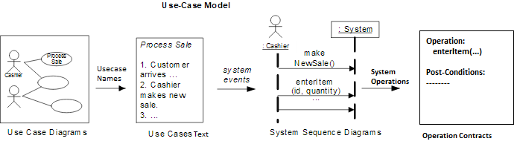
Example of a sequence diagram
An SSD shows, for a particular course of events within a use case, the external actors that interact directly with the system, the system (as a black box), and the system events that the actors generate .
Time proceeds downward, and the ordering of events should follow their order in the use case.
System events may include parameters.
This example is for the main success scenario of the Process Sale use case.
It indicates that the cashier generates makeNewSale, enteritem, endSale, and makePayment system events.
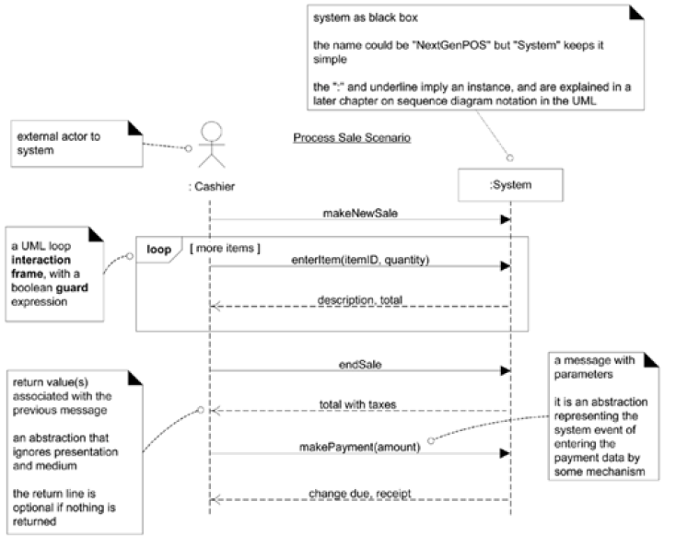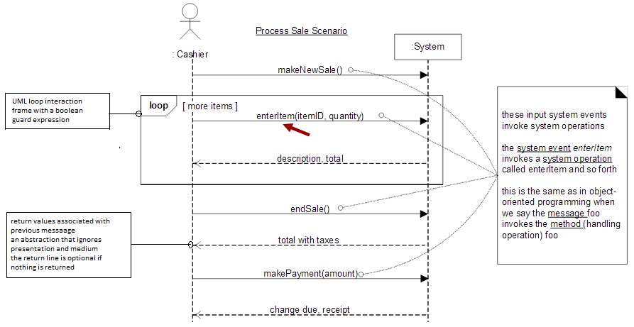

Significance of Drawing System Sequence Diagrams
It is required to design software to handle events from mouse, keyboard etc coming in to the system and execute a response
Software system reacts to three things
- External events from actors (human or computers)
- Timer events
- Faults or exceptions
So it becomes necessary to know the external/system events to analyze the system behavior
System sequence diagrams are drawn to investigate and define the behavior of a software application as a black box before going into detailed design of how it works
System behavior is a description of what a system does, without explaining how it does it and
System sequence diagram is a part of that description
SSDs and Use Cases
An SSD shows system events for a scenario of a use case, therefore it is generated from inspection of a use case. So there can be multiple scenarios in case of a system and those scenarios can be further elaborated by using individual system sequence diagrams to depict the system events.
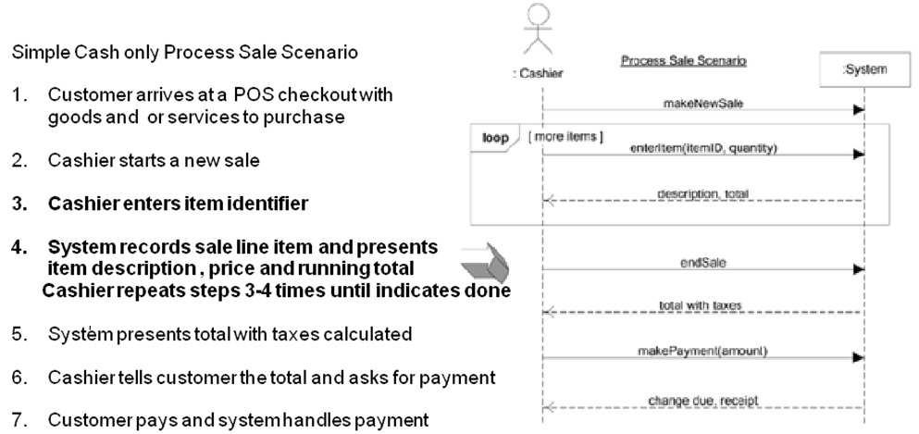
Like in case of an ATM system the use case scenarios make_withdrawal, make_balance_enquiry, maintain_ATM etc can be elaborated further by individual system sequence diagrams to identifying the system events pertaining to the individual scenario.

System Events and the System Boundary
To identify system events, it is necessary to be clear on the choice of system boundary.
For the purposes of software development, the system boundary is usually chosen to be the software (and possibly hardware) system itself; in this context, a system event is an external event that directly stimulates the software
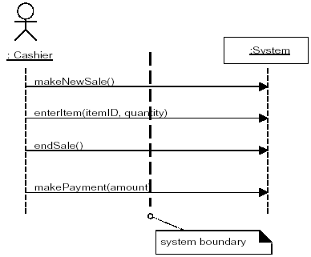
Consider the Process Sale use case to identify system events. First, we must determine the actors that directly interact with the software system. The customer interacts with the cashier, but for this simple cash-only scenario, does not directly interact with the POS system—only the cashier does. Therefore, the customer is not a generator of system events; only the cashier is.

Giving Names to System Events and System Operations
System events (and their associated system operations) should be expressed at the level of intent rather than in terms of the physical input medium or interface widget level.
It also improves clarity to start the name of a system event with a verb (add...,enter..., end..., make...)
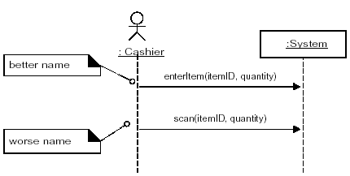
A system event is an external input event generated by an actor to a system.
An Event initiates a responding operation.
A system operation is an operation of the system that executes in response to a system events
When the Cashier generates the enterItem system event it causes the execution of the enterItem system operation (in this case the event is the named stimulus and the operation is the response)
So it is better to name a system event as enterItem rather than scan as scan is specific form of entering items into system

Recording System Operations
The set of all required systems operations is determined by identifying the system events, using parameters e.g. enterItem(UPC, quantity), endSale(), makePayment(amount)

How to make a Sequence Diagram
- Draw a line representing the system as a Black Box
- Identify each actor that directly operates on the system. Draw a line f or each such actor
- From the Use Case typical course of events text, identify the system (external) events that each actor generates. Illustrate them on the diagram.
- Optionally, include the use case text to the left of the diagram.
System Behavior – Contracts
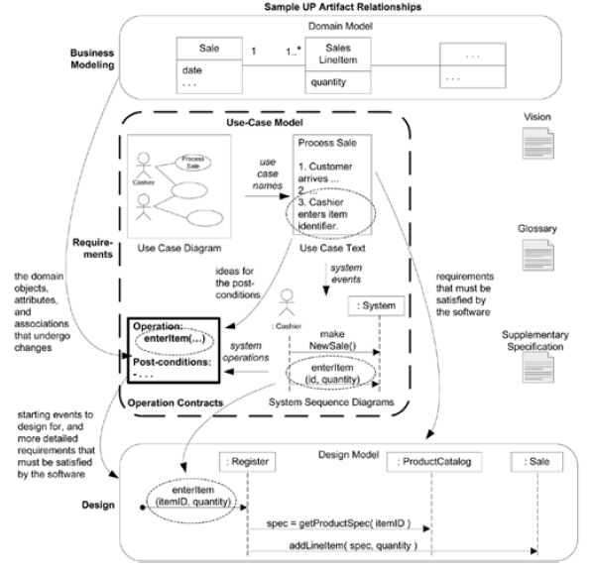
Contracts for operations can help define system behavior; they describe the outcome of executing system operation in terms of state changes to domain objects.
The UML contains support for defining contracts by allowing the definition of pre and post-conditions of operations.
Their creation is dependent on
- Development of Conceptual Model
- System Sequence Diagrams
- The Identification of System Operations

Contracts:
Use cases are the primary mechanism in the UP to describe system behavior, and are usually sufficient. However, sometimes a more detailed description of system behavior has value.
Contracts describe detailed system behavior in terms of state changes to objects in the Domain Model, after a system operation has executed.
It is a document that describes what an operation commits to achieve.
It is usually declarative in style, emphasizing what will happen rather than how it will be achieved.
It is common for Contracts to be expressed in Terms of Pre and the Post Conditions state changes
A contract can be written for an individual method of a software class or for a system operation

Contracts are written for each system operation to describe its behavior
System

endSale()
enterItem()

SSD, System Events, System Operations and Operation Contracts
Contracts are defined for system operations, the operations that the system offers in its public
interface to handle incoming system events.
System operations can be identified by discovering these system events
SSD shows system events or I/O messages relevant to the system
Input system events imply that the system has system operations to handle the events just like an OO message (a kind of even or signal) is handled by an OO method (a kind of operation)
The entire set of system operations defines the public system interface, viewing the system as a single class or component.
In the UML the system as a whole can be represented as one object of a class named System
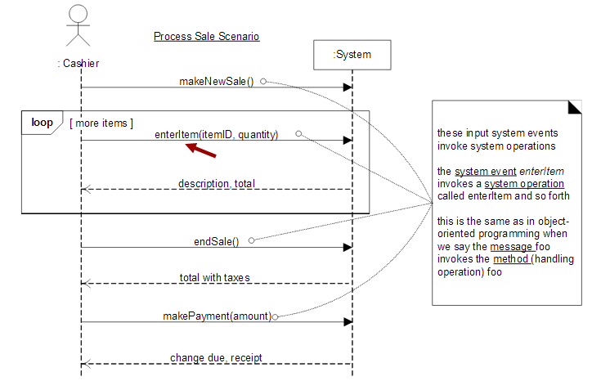
System operations handling input system events
Contract Sections
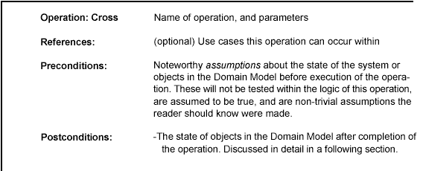

Example Contract: enterltem
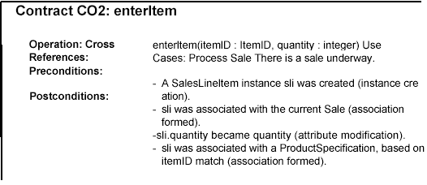
Post Conditions
The postconditions describe changes in the state of objects in the Domain Model and provide a detailed view of what the outcome of the operation must be
Domain Model state changes include instances created, associations formed or broken, and attributes changed.
(worse) Create a SalesLineItem
Postconditions are not actions to be performed, during the operation; rather, they are declarations about the Domain Model objects that are true when the operation has finished. after the smoke has cleared.
Express postconditions in the past tense, as they are declarations about a state change in past.
(better) A SalesLineItem was created.
(worse) Create a SalesLineItem.
In other domains, when a loan is paid off or someone cancels their membership in something, associations are broken.
Think about postconditions using the following image: The system and its objects are presented on a theatre stage.
1. Before the operation, take a picture of the stage.
2. Close the curtains on the stage, and apply the system operation (background noise of
clanging, screams, and screeches...).
3. Open the curtains and take a second picture.
4. Compare the before and after pictures, and express as postconditions the changes in the state
of the stage (A SalesLineltem was created...).
Guidelines: Contracts
Apply the following advice to create contracts:
To make contracts:
i. Identify system operations from the SSDs.
ii. For system operations that are complex and perhaps subtle in their results, or which are not
clear in the use case, construct a contract.
iii. To describe the postconditions, use the following categories:
- instance creation and deletion
- attribute modification
- associations formed and broken
Advice on Writing Contracts
State the postconditions in a declarative, passive past tense form (was ...) to emphasize the declaration of a state change rather than a design of how it is going to be achieved. For example:
(better) A SalesLineltem was created. .
(worse) Create a SalesLineltem.
Remember to establish a memory between existing objects or those newly created by defining the forming of an association.
For example, it is not enough that a new SalesLineltem instance is created when the enterltem operation occurs. After the operation is complete, it should also be true that the newly created instance was associated with Sale;
thus:
The SalesLineltem was associated with the Sale (association formed).
Operations
An operation is an abstraction, not an implementation. By contrast, a method (in the UML) is an implementation of an operation.
A UML operation has a signature (name and parameters), and also an operation specification, which describes the effects produced by executing the operation; the postconditions.
A UML operation specification may not show an algorithm or solution, but only the state changes or effects of the operation.
Operations contracts expressed with the OCL
Associated with the UML is a formal language: Object constraint Language (OCL)
Which can be used to express constraints in models
The OCL defines an official format for specifying pre and post conditions for operations as :
System: makeNewSale()
Pre: <statements in OCL>
Post:
Contract and other artifacts
Pre-conditions
These define the assumptions about the state of the system at the beginning of the operation.
Some worth pre-conditions are
Things that are important to test in software at some point during execution of the operation.
Things that will not be tested, but upon which the success of the operation hinges
Post conditions
To summarize, the post conditions fall into these categories:
i. Instance creation and deletion.
ii. Attribute modification.
iii. Associations (to be precise, UML links) formed and broken.
Point of Sale Terminal-Case Study
- Customer arrives at the point of sale terminal with the items
- The cashier enters the items into the Register by noting the item id and its quantity
- The system searches the price of each SalesLineItem and computes its subtotal
- The system finally computes the Grand Total of the entire Sale
- The cashier enters the Payment (amount tendered) made by the customer
- The system prints the receipt and displays the change amount.

i. Instance Creation and Deletion
After the itemID and quantity of an item have been entered, what new object should have been created? A SalesLineltem. Thus:
. A SalesLineltem instance sli was created (instance creation).
ii. Attribute Modification
After the itemID and quantity of an item have been entered by the cashier, what attributes of new or existing objects should have been modified? The quantity of the SalesLineltem should have become equal to the quantity parameter. Thus:
. sliquantity became quantity (attribute modification).
iii. Associations Formed and Broken
After the itemID and quantity of an item have been entered by the cashier, what
associations between new or existing objects should have been formed or broken?
The new SalesLineltem should have been related to its Sale, and related to its
ProductDescription. Thus:
. sli was associated with the current Sale (association formed).
. sli was associated with a ProductDescription, based on ItemID match
(association formed).
A post-condition that breaks an association:
Consider an operation to allow the deletion of line items. The post-condition could read "The selected SalesLineltem’s association with the Sale was broken." In other domains, when a loan is paid off or someone cancels their membership in something, associations are broken.
